Welcome to our second newsletter! I hope you were able to enjoy some activities provided last week. Feel free to send a picture or drawing to me at michelle.brenton@nbed.nb.ca and let me know if I could post it in the gallery on my website. I’d love to see how your children are staying active and healthy and how they are having fun – maybe your child will get a “shout out” in next week’s newsletter! Once again, you are not expected to complete everything. Choose activities that your children enjoy or are interested in trying. Have fun being active together! 😊
Move It Monday | 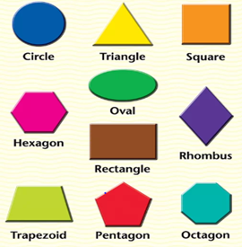  Let’s move – outside! Kids (and adults!) love a good scavenger hunt. Put a twist on the search by having kids find items of certain shapes. When all objects have been collected or seen, kids can then trace and colour in the items on a separate sheet of paper. If the objects are items that can’t be picked up, such as a clock on a wall, let kids use your smartphone to take a photo of the item.
Try It Tuesday | Nothing gets your heart racing like a good game of tag. To play Everybody’s It Tag, set some boundaries in your yard/play area. Someone counts down, 3-2-1 GO and everyone tries to tag each other. If you get tagged, perform 5 jumping jacks (or other exercise) before rejoining the game. You can’t “babysit” others while they are doing their jumping jacks. This game is continuous, so be sure to take breaks and drink plenty of water.
Wellness Wednesday | 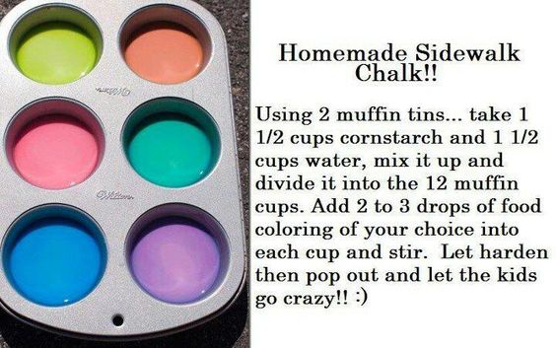  1. Make some chalk (to be used for an activity next week). Let your child do the measuring.  2. Then watch the Tying Shoe Laces song on YouTube here: https://youtu.be/BeSkBOYUlag or learn other ways to tie here: https://youtu.be/py99ND-qs1E You may find your child has a preferred method. Keep practicing!
This OR That Thursday | Unstructured play (bike, walk, dance party, make up a game, build a fort, etc) OR  Toss & Catch Challenges: You need an object to toss and catch: tennis ball, ball of socks, stuffed toy, etc…  1. Practice tossing and catching by yourself 10x  2. Toss, clap, and catch 10 x. Try to increase the amount of claps.  3. Toss, touch the floor and catch 10 x  4. Toss, turn around on yourself, and catch 10 x  5. Toss back and forth with a family member. After every 10 tosses and catches, take a step backwards.  *** Make the task easier, toss a bigger object, toss lower, catch with 2 hands.  ***More challenging – smaller object, toss higher (maybe outside) and catch with 1 hand or any other manoeuvre, that adds to the degree of difficulty.
Fitness Fun Friday | 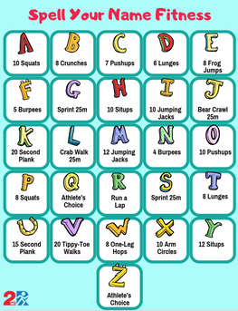  Spelling Fitness: Try using the letter chart and spell out your name or your some of your sight words. Do each exercise for 30 seconds.  P – 6 squats  L – crab walk 25 m  A – 10 squats  N – 4 burpees
On-line Anytime Activities | The Learning Station – Boom Chicka Boom!  https://youtu.be/69f9sCwhwYk  Mr. C on YouTube; students are familiar with this song; he’s added movement choices though!!  https://youtu.be/LybWBX1jaBg  Website of the Week: www.keepingkidsinmotion.com

